**Overview**

Our current version of Atlas is only compatible with Internet Explorer mode in MS Edge.

**Steps**

1. Open MS Edge, click on the three dots button in top right > Settings > Default Browser

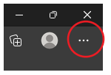



1. Next to “Allow sites to be reloaded in Internet Explorer mode” select Allow in the drop-down.

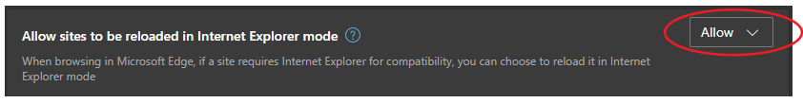

1. When prompted to restart browser, select Restart button
2. Enter eLabs site into URL search bar: <https://nahealth.elaborders.com/>
3. Select the three dots button in top right again, then select “Reload in Internet Explorer Mode”



1. Now you can use eLabs successfully with MS Edge browser in IE mode.

**COMPLETE**